Advanced Web Application Development

(COMP229- Fall)

Team Project-Part 1

M SQUARE LIBRARY

Venkata kodithala: 300920874

Muntafia Islam: 300790731

Professor:

Mark MacDonnell

Friday, 18th Nov 2016

**Table of content**

Contents

Team Logo 3

Details description of the web page 3

(Done by group) 3

Version histoty- github 3

Link 3

Team project Contributors 4

Commits by Venkata kodithala 4

Commits by Muntafia Islam 5

Typography and color 5

Wireframes 6

Home Page (Done by Muntafia) 6

Registration Page(Done by Muntafia) 7

Login/logout (Done by Muntafia) 8

Error Message(Done by Muntafia) 8

Book Page (Done by Venkata kodithala ) 9

User page (Done by Venkata kodithala) 10

Screen Capture (sample of each site’s templates) 11

Visual Studio (pages and asset folder-Created) 11

Asset folder containing images used in the webpage 12

Home Page.aspx 12

RegistrationPage.aspx 13

Book Page 13

Userpage.aspx 14

# Team Logo



# Details description of the web page

## (Done by group)

We made a website name M Square. It is an ASP.Net web forms Application that tracks personal(user’s) library books. The website contains couple of different pages with many function and activities.

We have our Home page, that will track number of items in the collection, display recent additions, currently loaded count and other relevant details. The item(books) will be display details information such as (ISBN/UPC, title, format etc).

The we will also measure a point/review score for the title, and link to the official or publisher’s site for the item. The site will allow for updating/adding these details. It is a very user friendly web application.

# Version histoty- github

## Link

<https://github.com/monicakodidala/Comp229-TeamProject>

## Team project Contributors

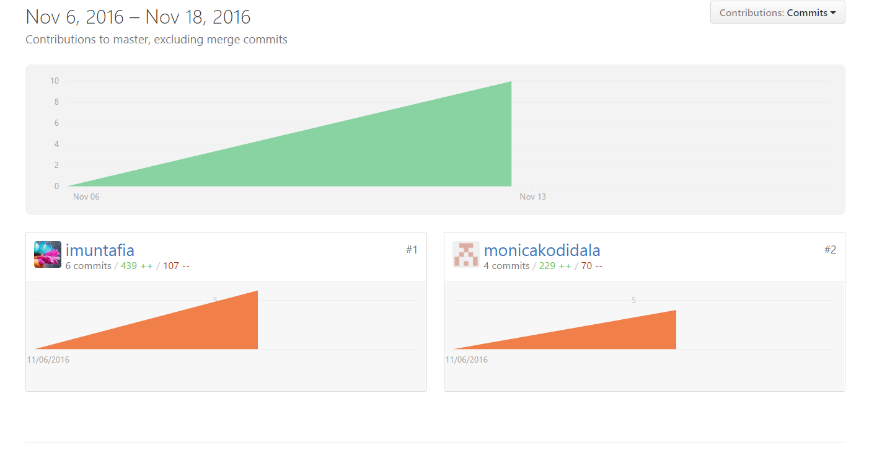

## Commits by Venkata kodithala

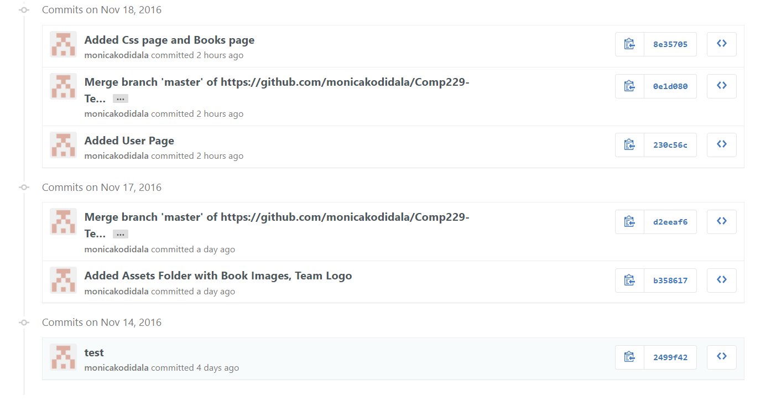

## Commits by Muntafia Islam

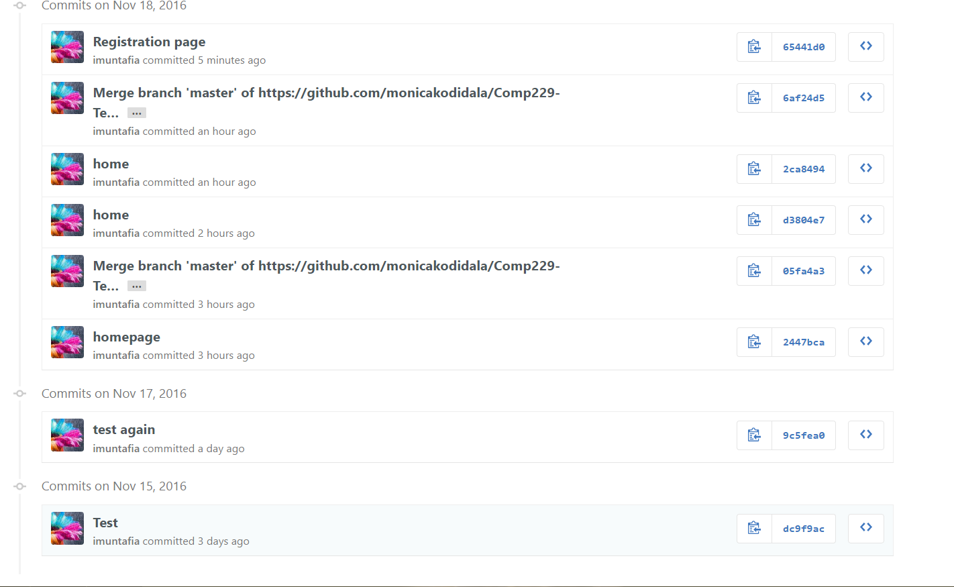

# Typography and color

On our we will be using font Calibri(Body) and Times New Roman. Bold text. We used varies types of font sizes from 14-24 (small to large text size). Except for the images our webpage will be in black-white letters.

# Wireframes

## Home Page (Done by Muntafia)

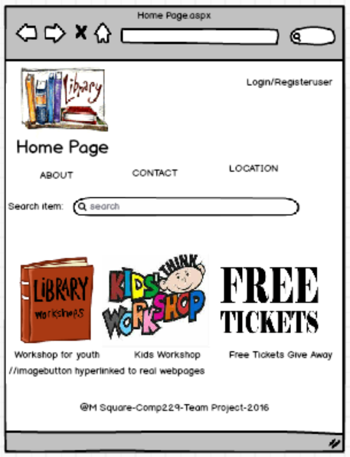

## Registration Page(Done by Muntafia)

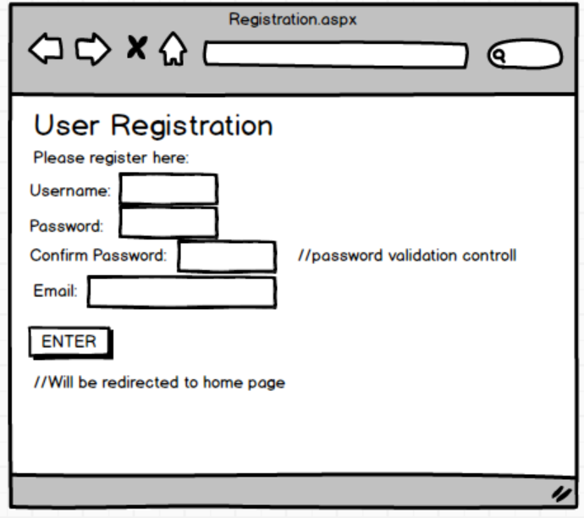

## Login/logout (Done by Muntafia)

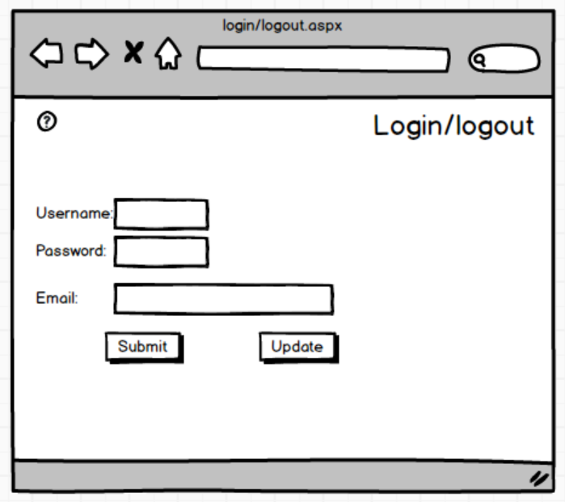

## Error Message(Done by Muntafia)

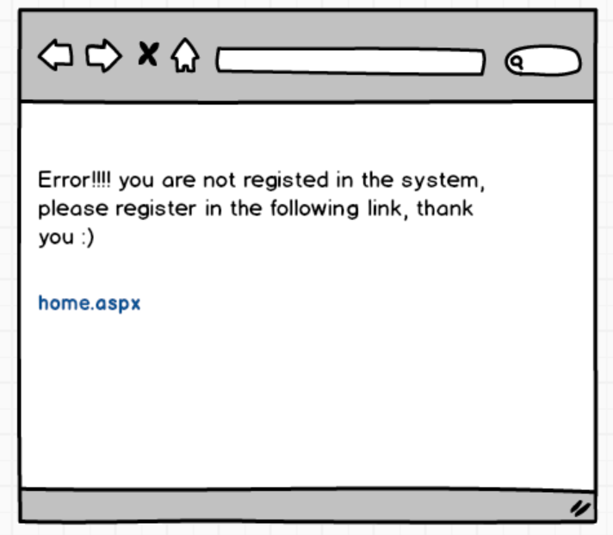

## Book Page (Done by Venkata kodithala )

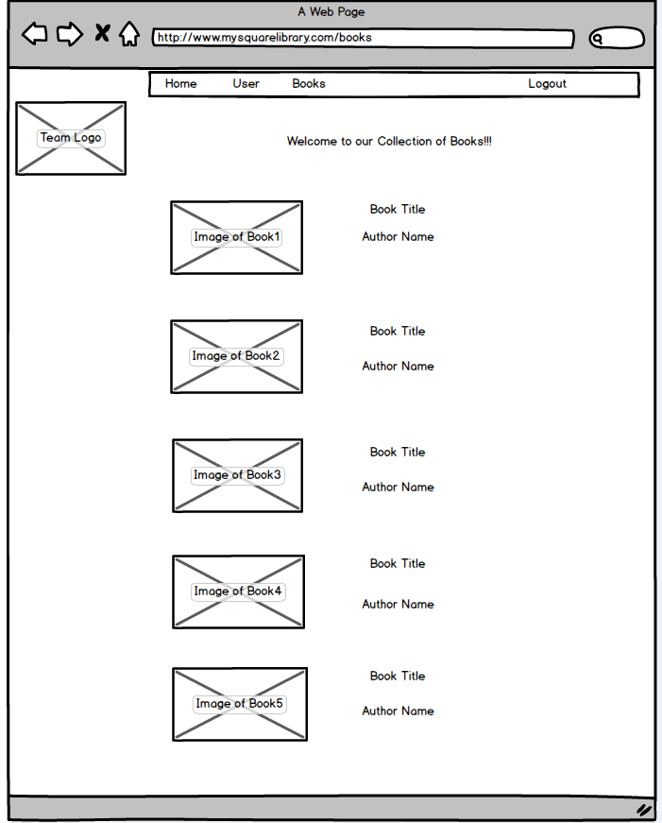

## User page (Done by Venkata kodithala)

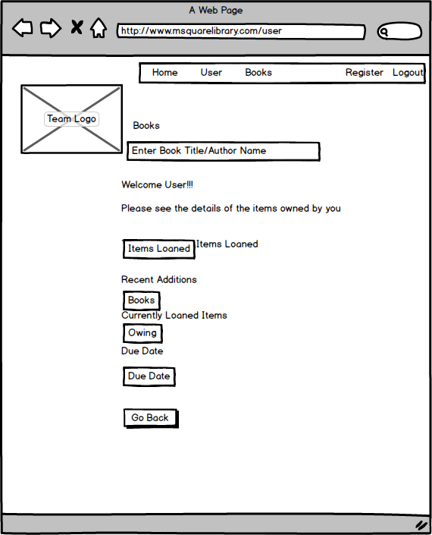

# Screen Capture (sample of each site’s templates)

## Visual Studio (pages and asset folder-Created)

# 

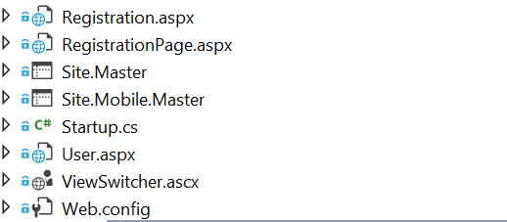

## Asset folder containing images used in the webpage

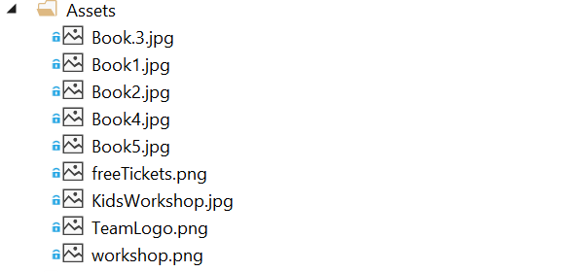

## Home Page.aspx

//page created by Muntafia

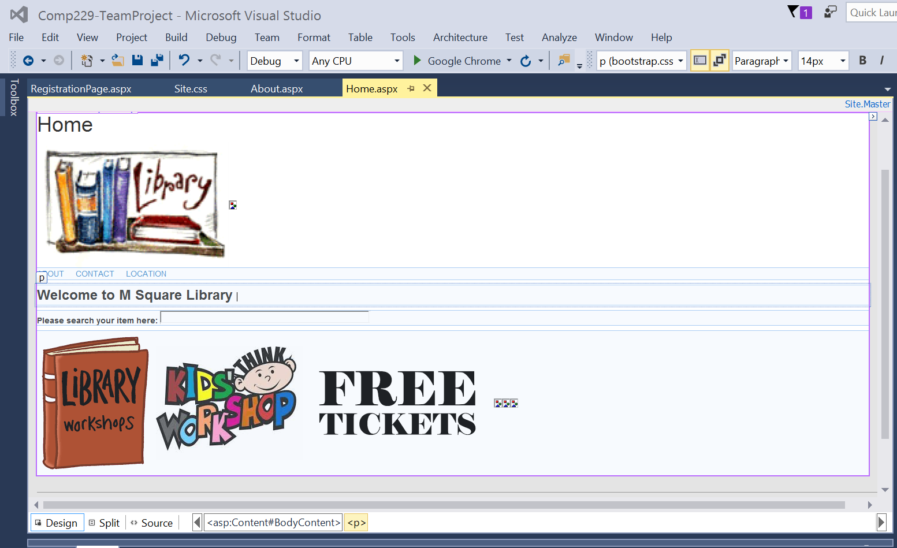

## RegistrationPage.aspx

//page created by Muntafia

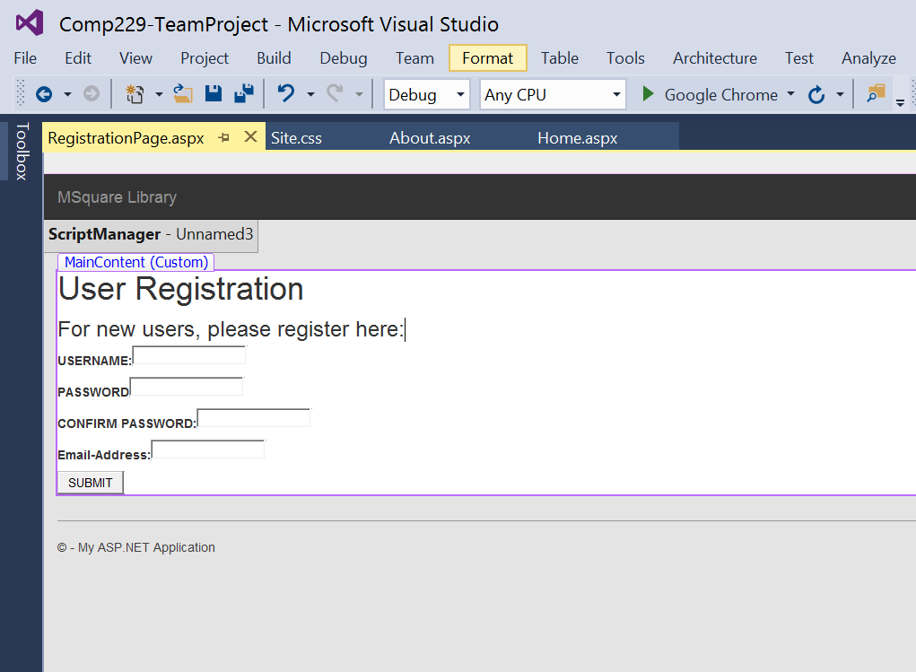

## Book Page

//page created by Venkata kodithala

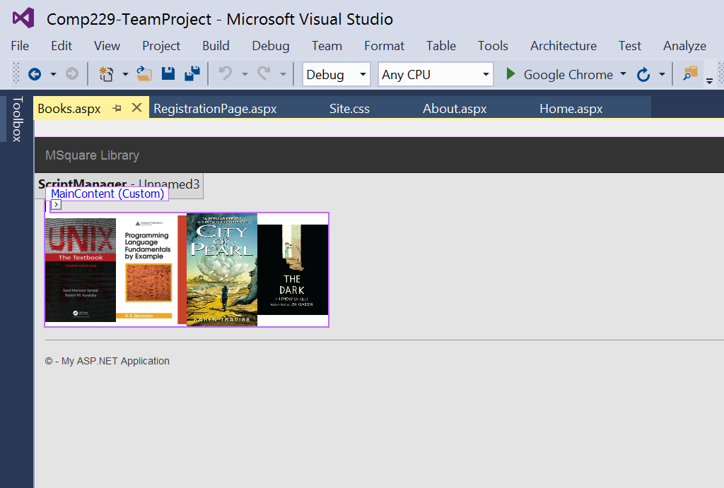

## Userpage.aspx

//page created by Venkata kodithala

